**Project report:**

Presented by: Namratha Jonnalagadda

HarshaVardhan Jonnalagadda

Thushar Mohan G

Preksha Reddy

Title: STOCK PREDICTION USING THE REGRESSION MODEL AND MACHINE LEARNING MODELS

Date: 12-12-2022

This summary report shows how using different Models and forecasting models helps in accurately predicting or forecasting the stock price of a company.

# Analytical Overview:

# All variables were first subjected to data analysis to determine how they related to one another and to make sure that all variables had a normal distribution.

# We used Prophet (Additive Regression Model) and various machine learning algorithms to construct a model for predicting stock price.

# Models Used:-

We trained and tested the data using several models and methodologies to obtain the best forecast.

* + PROPHET Regression Model
  + Machine Learning Models- Decision Tree and LOOCV

# Model Used:

* Stock Forecasting using the prophet Regression Model.
* Stock Forecasting Using the Machine Learning Models
* Loose one out cross validation.

# Conclusion :

* So we can see from prophet regression model that there is an increase in the stock value over the period of time.
* a decision tree algorithm executes a series of recursive operations, and when you plot these operations on a screen, the visual appears to be a large tree
* Stock price = Dividend / ( i-g )
* g(t) + s(t) + h(t) + t = y(t) { prophet regression }

**Appendix 1:-**

**Appendix 2:-**

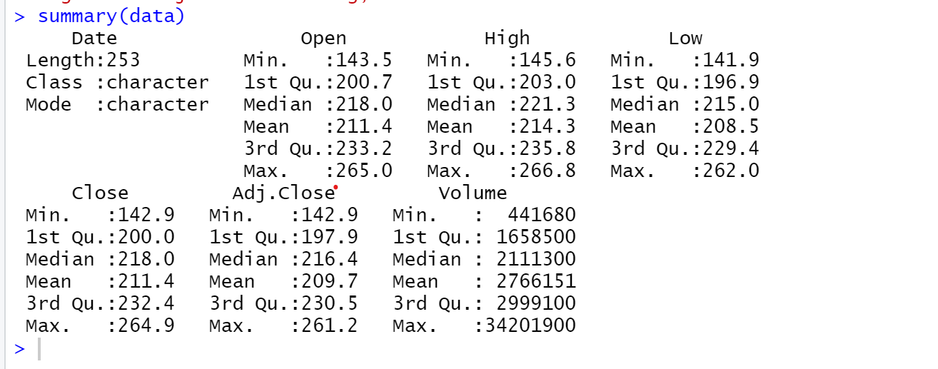

**Appendix 3:-**

*Fig 1:- Prophet Model*

*Fig 2:- The Time series Graph of the Average FEDX Stock Value :*

*Fig 3: - The Time series Graph of the Closing value fedx Stock :*

*Fig* ***4:-*** *LOOSE ONE OUT CROSS VALIDATION ON THE DECISION TREE*

